Questionnaire date: " " 20

Order of synchronous electric motor type:

(Specify the type of ordered electric motor)

ATTENTION! Designed by customer questionnaire is a legal document at a resolution of controversial issues in delivery and claims. The questionnaire must be signed, and have a date stamp.

Company:

Location:

 | Position: |  |  |  |  | E-mail:
The contact | FULL NAME: |  |  |  |  | E-mail:
The contact |  |  |  |  |  | Date of completion: " " |  |  |  | 20

The purpose of the order of the equipment:

New construction

Basic data of ordered motor:

replacement manufacturing number _____ year of production

(Specify the brand of the electric motor to be replaced)

installation on existing concrete monumental foundation
installation on base frame of available engine

Rated power: |  | kW
Rated Speed: |  | rpm | amount of poles
Rated voltage (Un): |  | V

Deviation from Un voltage: |  | standard, +5% |  |  |  |  |  |  |  | Other: from - |  |  |  |  |  |  |  |  |  |  | % to + |  |  |  |  |  | %
Nominal frequency of network: |  | standard, 50 Hz |  |  |  |  |  |  |  | other |  |  |  |  |  | Hz power
Power factor (cos φ): |  | standard, cos φ = 0,9 |  |  |  |  |  |  |  | other cos φ =
Mode operation: |  | standard, S1 |  |  |  |  |  |  |  | other |  |  |  |  |  | , PT |  |  |  |  | %
 |  | standard (Y, "Star")
Stator winding connection scheme: |  |  |  |  |  |  |  |  |  | triangle (∆)
Required insulation class: |  | standard "F" |  |  |  |  |  |  |  | other
 |  | (with using the class B)
The design performance of engine:
Degree |  | standard (IP21) |  |  |  |  |  | IP44 (or IP43) |  |  |  | IP00 |  |  |  |  |  |  |  |  |  | Other IP
Estimated method of cooling for engines with IP43 or IP44 degree of protection:
 | Open-cooling cycle: |  |  |  |  |  |  | The closed refrigeration cycle (with water):
No data | ICA11 / IC1A1 | ICA17 / IC1A7 |  |  |  |  |  | ICW37A91 / IC9A1W7 |  |  |  |  |  | ICW37A81 / IC8A1W7
 | ICA37 / IC3A7 |  |  |  |  |  |  | ICW37A97 / IC9A7W7 |  |  |  |  |  | ICW37A86 / IC8A6W7
The need to supply external water air cooler (for |  |  |  |  |  |  |  | standard (not required)
installation outside of engine): |  | IM 7311 (IM 7312) |  |  |  |  |  | is required
Installation design: |  |  |  |  |  |  |  |  |  | IM 7621 (IM 7622)
Installation design: |  | IM 7321 (IM 7322) |  |  |  |  |  |  |  | other, IM
The dimension of slide |  | No data |  |  |  |  |  | running end side ( |  |  |  |  |  |  |  |  |  |  |  |  | ) × ( |  |  |  |  |  |  |  | ) mm
bearings:
bearings: |  |  |  |  |  |  |  | slip ring side: ( |  |  |  |  |  |  |  |  |  | ) × ( |  |  |  |  |  |  |  |  | ) mm
Lubrication of slide bearings: |  | ring |  |  |  |  |  |  |  | combined
The need to supply external oil |  |  |  |  |  |  |  |  |  | standard (no, not required)
station for bearings: |  |  |  |  |  |  |  |  |  | required
The running end of shaft (number): |  | standard (1 shaft end) |  |  |  |  |  |  |  | Special (2 end)
Running end of shaft (dimensions): ^{diameter} |  |  |  |  |  | mm |  |  |  | no data
 | length |  |  |  |  | mm
* Rotation direction: |  | right |  |  |  |  |  | left |  |  |  |  |  |  |  |  | reverse
Placing outlet ends of stator |  | 1 right terminal box |  |  |  |  |  |  |  | down into the foundation pit
winding *: |  | 1 left terminal box |  |  |  |  |  |  |  | (Without terminal box)
 |  | 2 terminal boxes, right and left |  |  |  |  |  |  |  | Other:
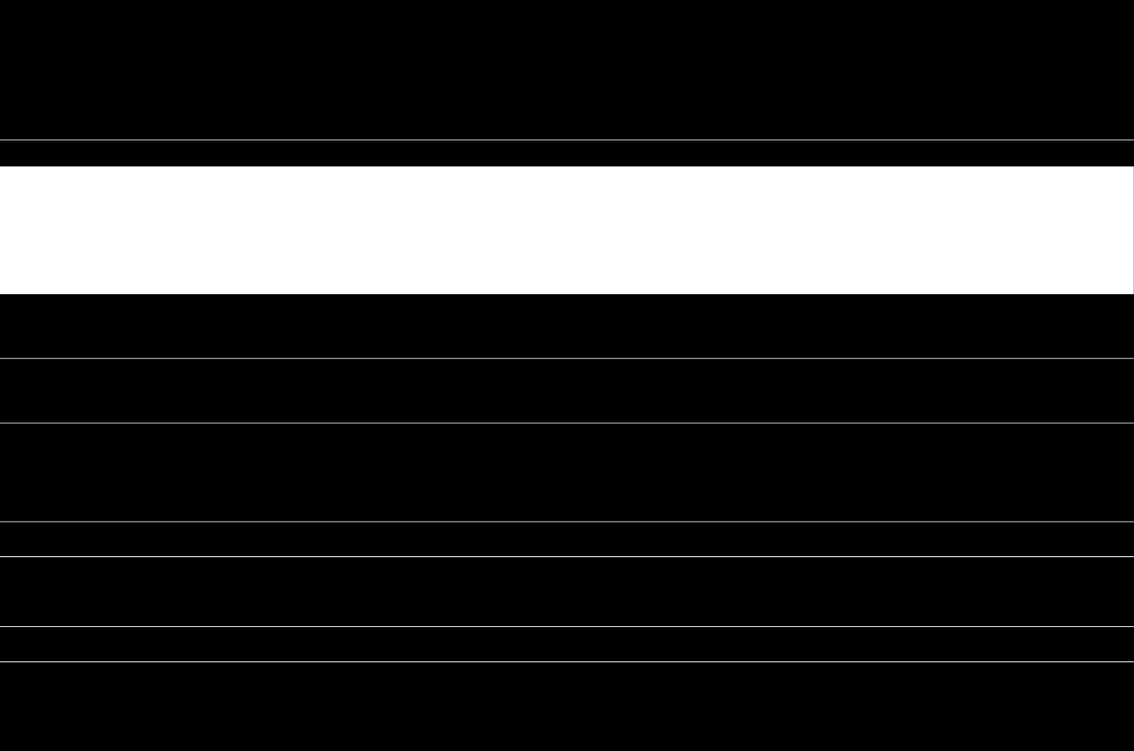
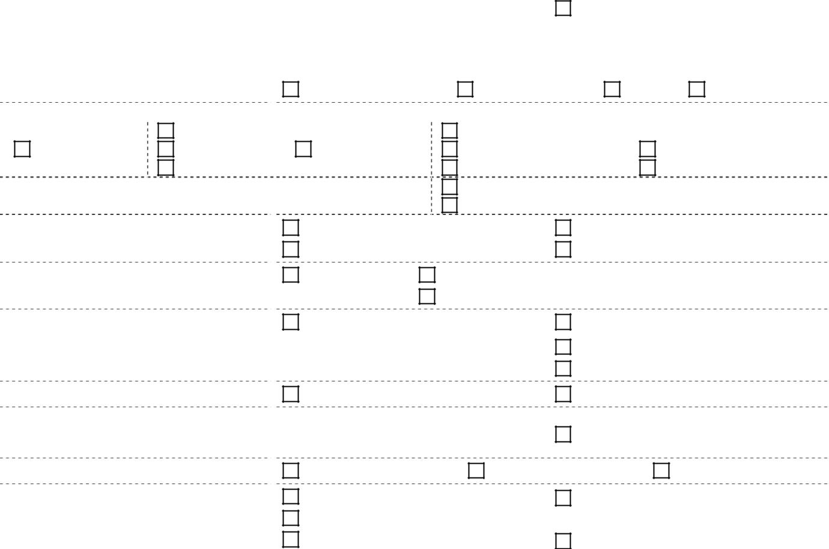

- Note: The view is from the running end of the shaft (the part of the drive mechanism). For engines with two shaft ends, the view is from the side opposite the slip rings.

Environmental conditions

Climatic performance and kategory | standard (UHL4) |  |  | other
according to ISO 15150
according to ISO 15150 | standard for UHL4 |  |  | other: from - |  |  |  |  |  |  |  |  |  | ° C to + |  |  |  |  |  | °
Ambient temperature:
Ambient temperature: | (From + 1 ° C to + 40 ° C)
Relative humidity: | standard for UHL4 |  |  | other |  |  |  |  | % at +
Relative humidity: | (No more than 80% at 25 ° C)
Height above sea level: | Standard (up to 1000 m) |  |  | other |  |  |  |  |  |  | m
aggressive environment presence: |  |  |  |  | ; content%
(Corrosive atmosphere, solutions of acids, alkalis, conductive dust)
Stator Temperature Control:
Resistance thermometers (TC) | NSH 50M |  |  | NSH Pt' 100 (100П)
with NSH: | NSH Pt100 |  |  | other: NSH
compounds scheme: | 2-wire |  | 3-wire |  |  |  |  |  |  |  |  | 4-wire
Number of vehicle: | standard |  |  | Other: Cu |  |  |  |  |  |  |  |  | pcs. + Fe |  |  |  |  |  |  | psc.
Bearing Temperature Control: | (Cu - 6 pc .; Fe - 3 pcs.)

Resistance thermometers (TC)
with NSH:

Number of vehicles:

Barometric showing TKP-160Cr

drive mechanism

NSH 50M | NSH Pt' 100 (100П)
NSH Pt100 | other: NSH
standard: | Other:
each bearing - 1 pcs. | each bearing - for |  |  | psc.
standard (not required) | Yes, needed

Type of drive mechanism: | pump | pump for abrasive slurries (precoat pump);
constant current generator | compressor | mill (cement, grind etc.)
constant current generator | fan | other

Mark (size) of drive mechanism: |  |  |  |  |  |  |  |  |  | year of issue
Manufacturer:
Moment of inertia (J) or swing |  | J = |  |  |  |  |  |  | kg*m² | No data
moment of the drive mechanism (GD²): |  | GD²= |  |  |  |  |  | kg*m²
Load Feature: | quadratic (M ~ n²) |  |  |  |  | linear (M ~ n) |  |  |  | constant (M = const)
Average static torque resistance mechanism |  | Standard pumps: 0.4 Mnom
for start-up *: |  | Standard for mills: 0.8 Mnom
No data |  | other: |  |  |  |  | Mnom.

- Note: It is recommended to provide the time dependence of the resistance mechanism of the engine speed for the entire start-up period.

The type and brand of used coupling half:
Weight is placed on the working end of the shaft
coupling half: |  | kg | No data
Mass countershaft (Engine drive industrial fans) |  | kg
Mass countershaft (Engine drive industrial fans) |  | kg | No data
Axial forces transmitted to the motor bearings of | standard (not transmitted) |  | another (passed):
the mechanism: |  |  | - in the direction of the pump: |  |  | kg
 |  |  | - away from the pump: ___________kg

speed control

requires speed control

Speed control range:

Estimated time of work on minimum speed

Need for additional configuration of the engine:

 | Does not require speed control
from | rpm |  | before |  |  | rpm
_______minutes per hour; |  |  |  |  |  | hours per day;
 | encoder type |  |  |  |  | forced motor cooling fan
 | tachogenerator |  |  |  |  | forced motor cooling fan
 | rotor position sensor

start-up procedures

Engine start with mechanism: |  | Idling start |  |  |  |  |  |  |  | load start
Starting |  | straight |  |  |  |  |  |  |  | frequency converter (inverter)
 |  |  |  |  |  |  |  |  |  | voltage converter
Desired multiplicity initial starting torque of engine |  |  |  |  |  |  |  |  |  | _____Mnom
(In relative terms):
starting current limitation (in relative terms): |  |  |  |  |  |  |  |  |  |  | Inom
nom size falling supply voltage at direct engine start
(percentage of nominal value) based on electric power |  |  |  |  |  |  |  |  |  |  | % Unom
and their status on-site:
Projected number of starts |  | cold |  |  |  |  |  |  |  | hot
day / month: |  | / |  |  |  |  |  |  |  | /
exciter
exciter supply |  |  |  |  | required |  |  |  |  |  | not required
Type of agent (preferred for
Consumer) and manufacturer:
Required degree of protection of pathogen: |  |  |  |  | IP21 |  |  |  |  |  |  | IP54
Needed power supply: |  |  |  |  | -220V |  |  |  |  |  | ~220 V, 50 Hz
 |  |  |  |  | Other: - |  |  |  | V |  | Other: ~ |  |  |  |  | V, |  | Hz
engine management: |  |  |  |  | local |  |  |  |  |  |  | distance
Required network interface: |  |  |  |  | Profibus DP |  |  |  |  |  | Other:
 |  |  |  |  | Modbus TCP |  |  |  |  |  | Not required
Required telemetry: |  |  |  |  | RS-232 |  |  |  |  |  | Not required
 |  |  |  |  | RS-485
Assumed exciter with soft starter or frequency converter: |  |  |  |  | Yes |  |  |  |  |  |  | no
Current transfer ratio at customer’ high voltage unit |  |  |  |  |  | / 5 A

Spare parts

standard: brush EG4-25x32x64

Size and mark the desired brush:
other: brand brush dimensions

Required delivery of expanded spare parts:

Required expanded spare parts (Based on the engine 1):

Operational documentation (OD)

required |  |  |  |  |  | not required
plain bearings - |  |  |  |  |  |  |  | psc.
labyrinth seal (oil trap) - |  |  |  |  |  |  |  |  | psc.
Oil-lubricated ring - |  |  |  |  |  |  | psc.
brush - |  | psc.
brush holder - |  |  |  |  |  | psc.

 |  | Standard: 1 pcs. on paper
Number of copies of OD |  | Other: |  | psc. on paper
 |  | Other: |  | psc. on an electronic medium (CD-ROM)
Language design OD |  | Ukrainian |  |  | English
Language design OD |  | Russian |  |  | other:

Completeness of delivery (motors for installation on existing foundation beams engine)

Supply anchoring reinforcement (foundation bolts, nuts, washers, plates):

Delivery of foundation beams:

Delivery of enclosures slide bearings:

Signature of the responsible official person ordering the enterprise:

required | not required
required | not required
required | not required

L.S.

